EBS volumes -------🡪

1. Create ebs volume on AZ a and attached to ec2 on AZ b
2. Created volume on us-east-1

Volume is created and ready to be attachable to ec2

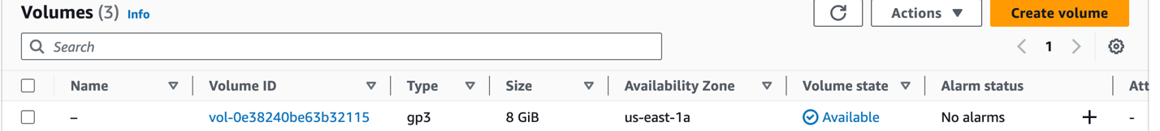

1. Select volume --🡪 Actions --🡪 Attach volume ---🡪

Note we cannot select instance called InstanceStore-server or EBS-Testing Because there are created on other AZ.

Now its time to create snapshot from from EBS volume ?

1. Select ebs volume
2. From Actions --🡪 Create Snapshot

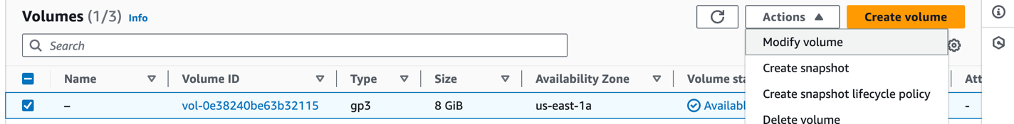

Now snapshot has been Successfully created.

EC2 --🡪 Elastic Block store --🡪 snapshots

Now from snapshot we can

1. Create volume from snapshot on other AZ
2. Copy snapshot to other region

Create volume from snapshot ?

Note we select different AZ for volume create from snapshot

Now volume has been created Successfully.

Now this ebs volume can attached to any ec2 exists on this AZ.

Select it --🡪 Actions --🡪 Attach volume --🡪 select instance

Then attach volume .

And then ssh to machine

1. Create file system for volume
2. Create mount point
3. Mount disk
4. Update fstab